Question 1

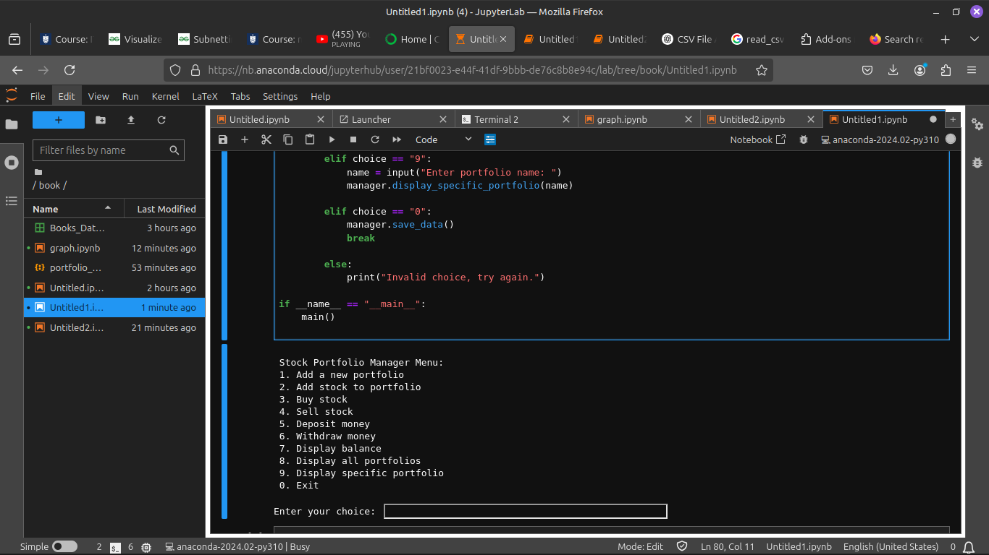

Question 2

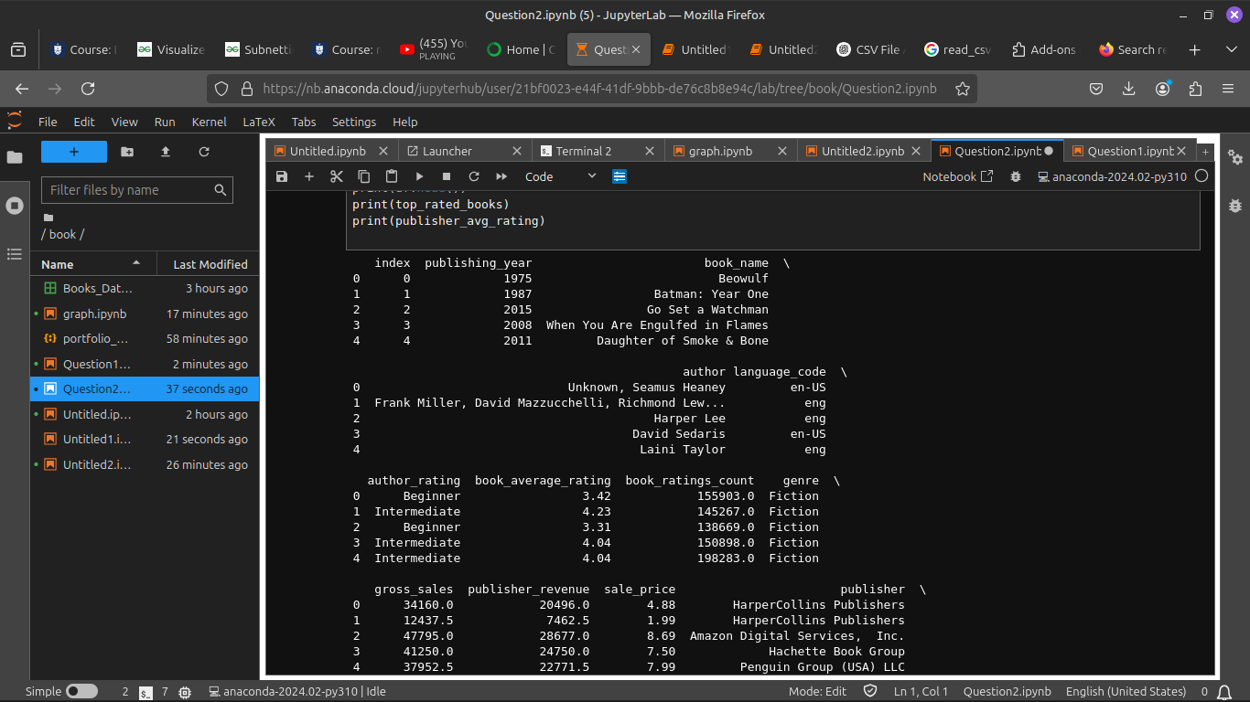

Question3

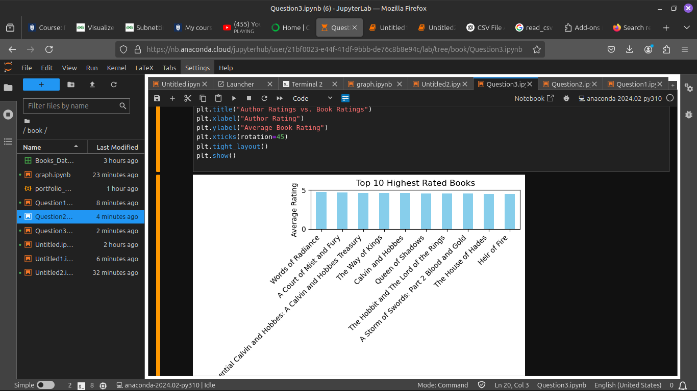

**Reference list:**

*Books_data.csv*. [Accessed 21 March 2025]

McKinney, W. (2010) *Data Structures for Statistical Computing in Python*. Proceedings of the 9th Python in Science Conference, pp. 51–56.

The Pandas Development Team (2023) *pandas: Powerful Python Data Analysis Toolkit*. Available at: <https://pandas.pydata.org/> (Accessed: 21 March 2025).

Python Software Foundation (2023) *csv – CSV File Reading and Writing*. Available at: <https://docs.python.org/3/library/csv.html> (Accessed: 21 March 2025).

Seaborn Development Team (2023) *Seaborn: Statistical Data Visualization*. Available at: <https://seaborn.pydata.org/> (Accessed: 21 March 2025).

Matplotlib Developers (2023) *Matplotlib: Visualization with Python*. Available at: <https://matplotlib.org/> (Accessed: 21 March 2025).